Data types from the following options

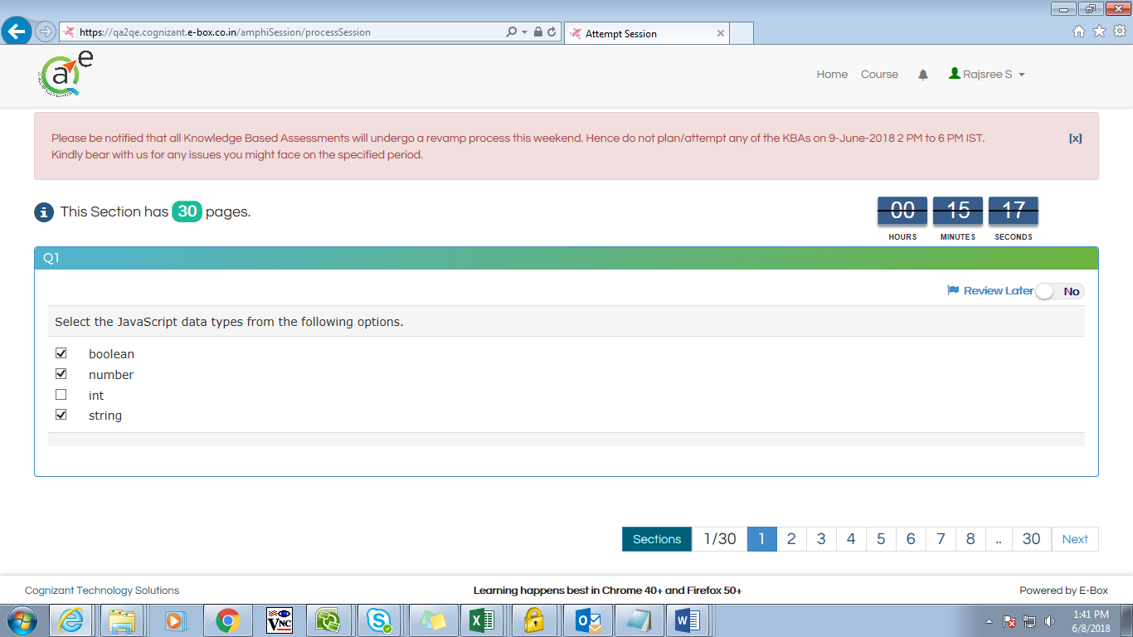

Choose the Window object properties

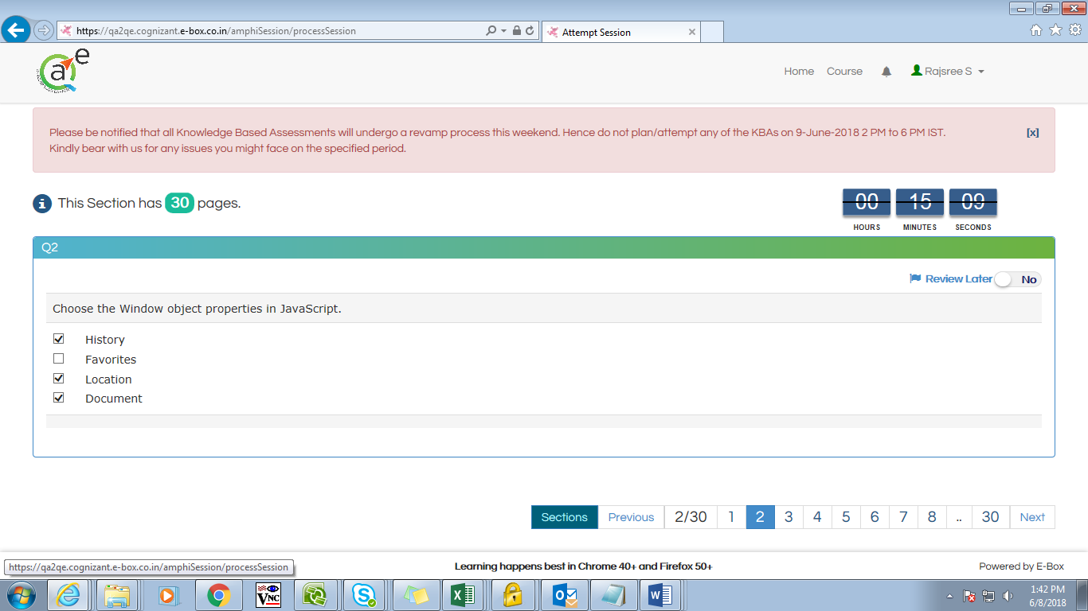

If an exception is thrown

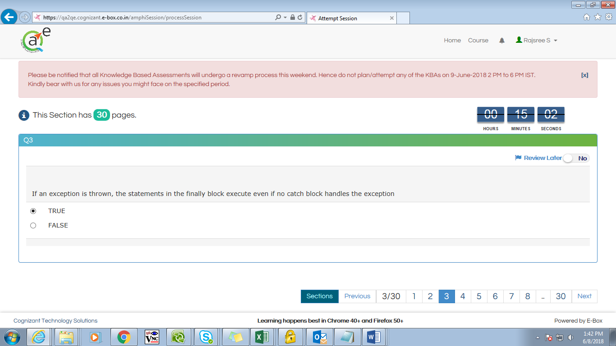

In JavaScript, Objects are passed by value

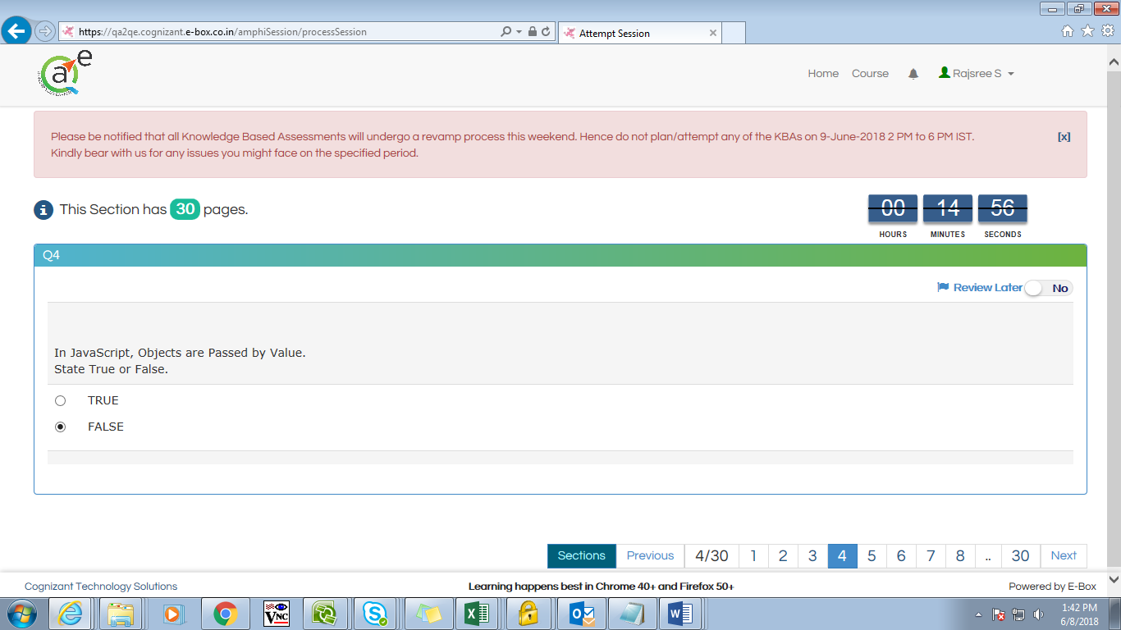

Chose the JavaScript keywords from the following options

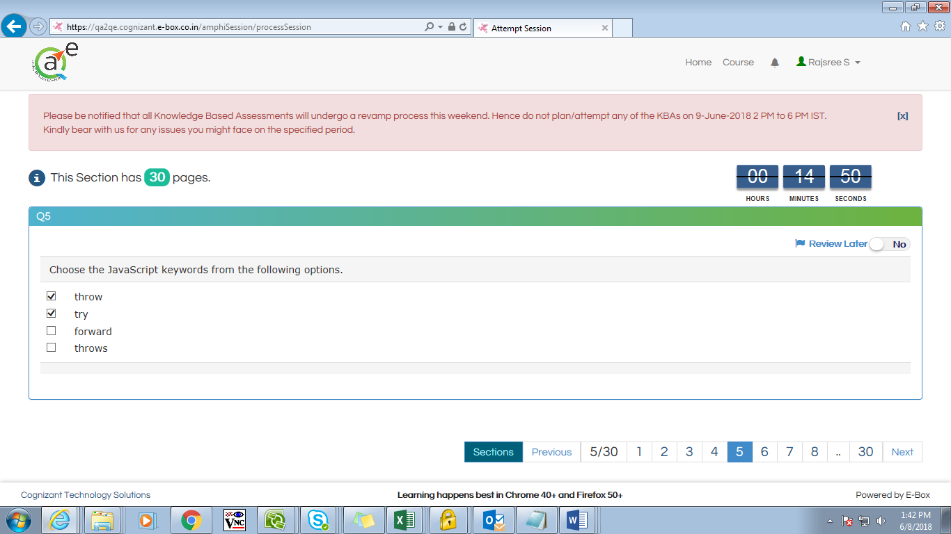

JavaScript uses prototypal or differential inheritance

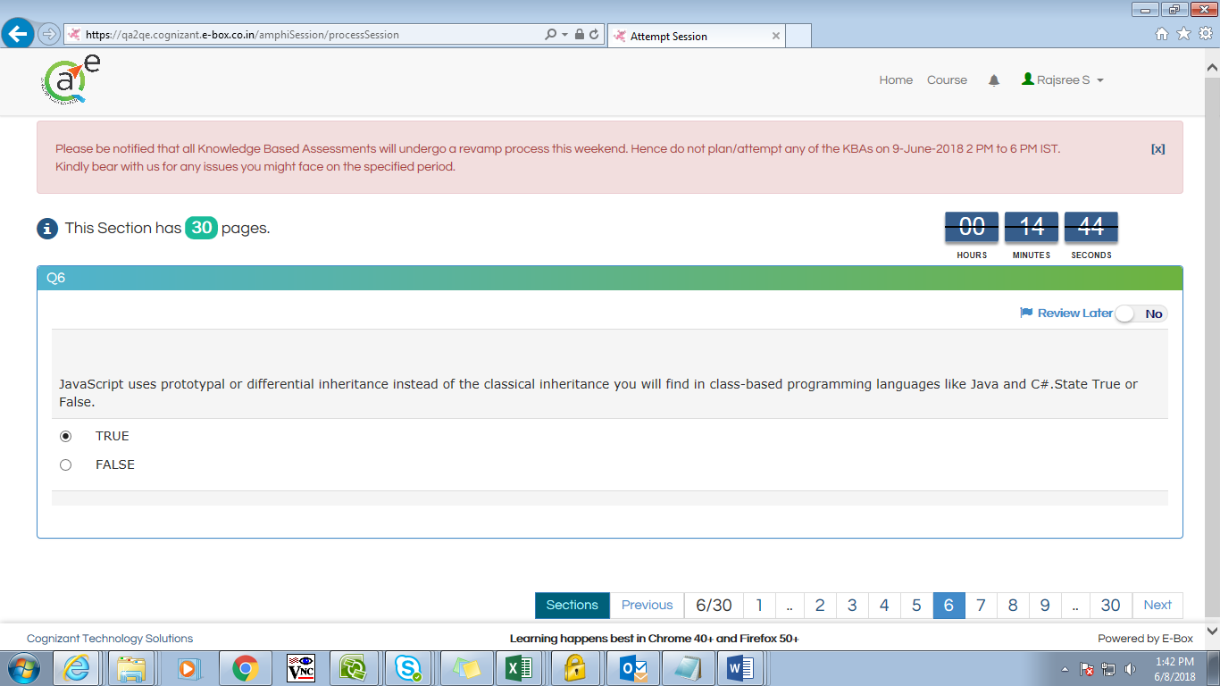

The Browser Object Model

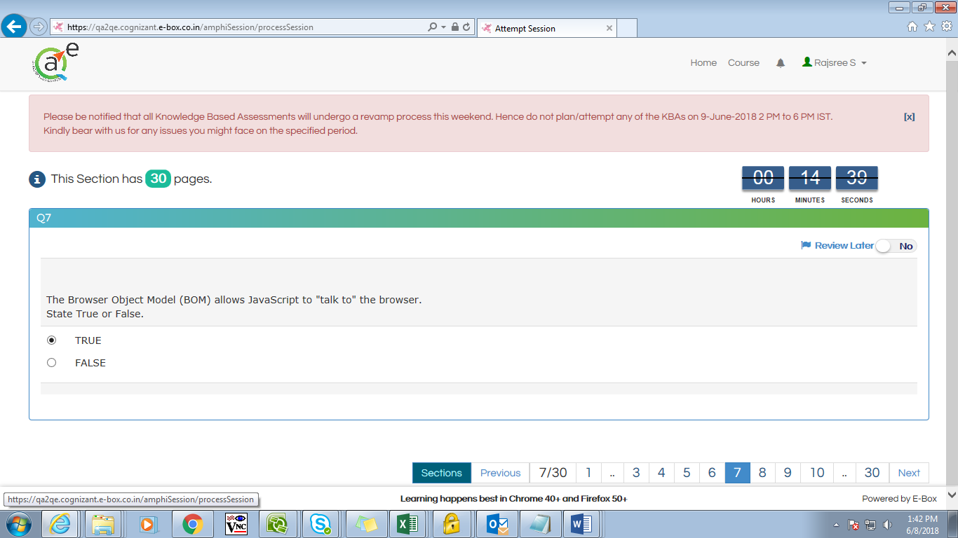

Choose the correct option that helps to get the browser

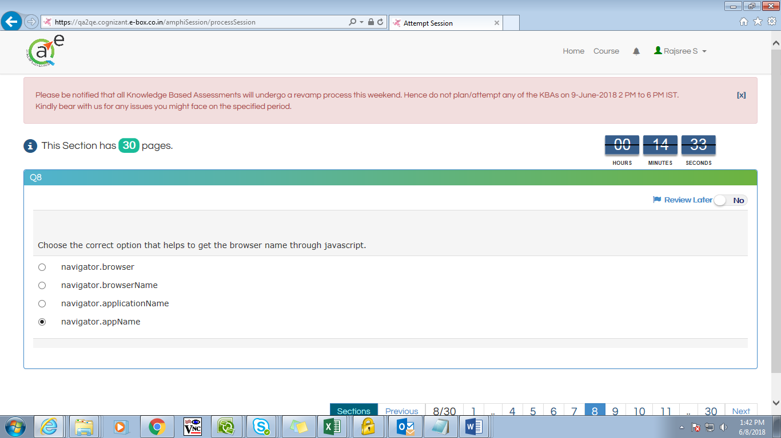

Does JavaScript allow exception handling?

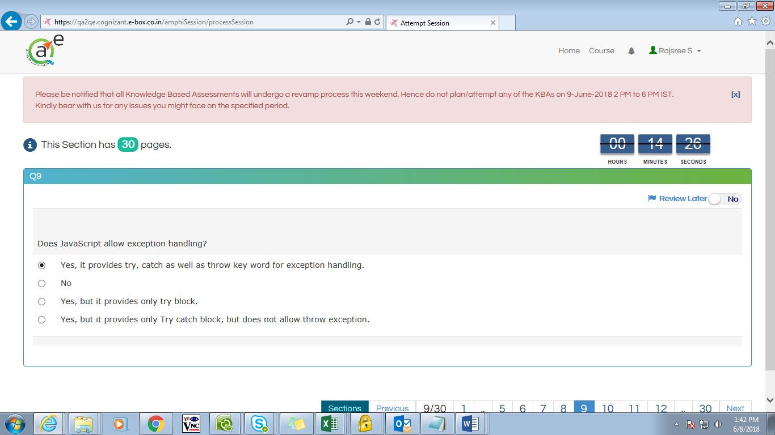

Which of the following is not a valid variable name?

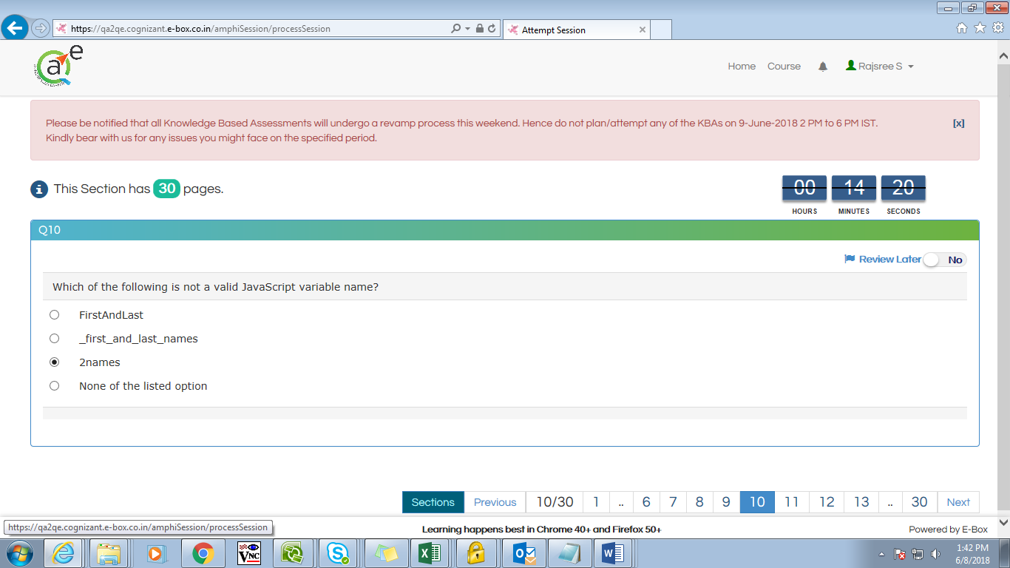

How do you write a conditional statement for executing

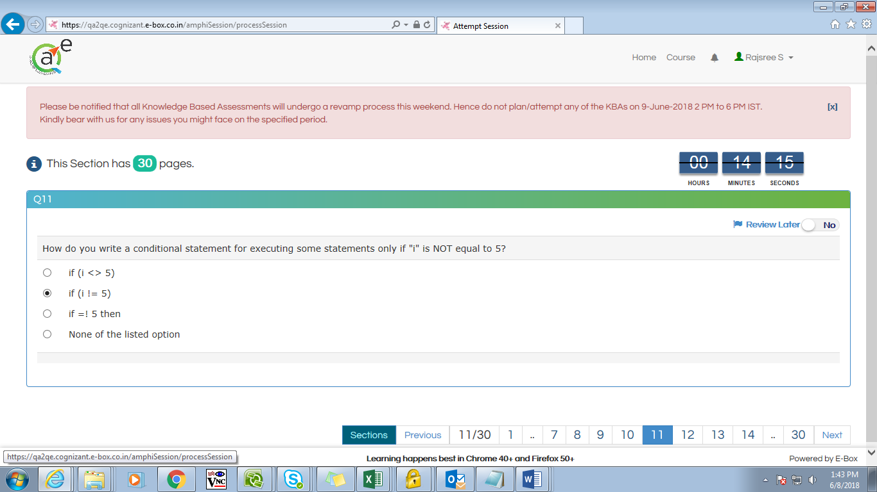

Which event occurs when the value of an element

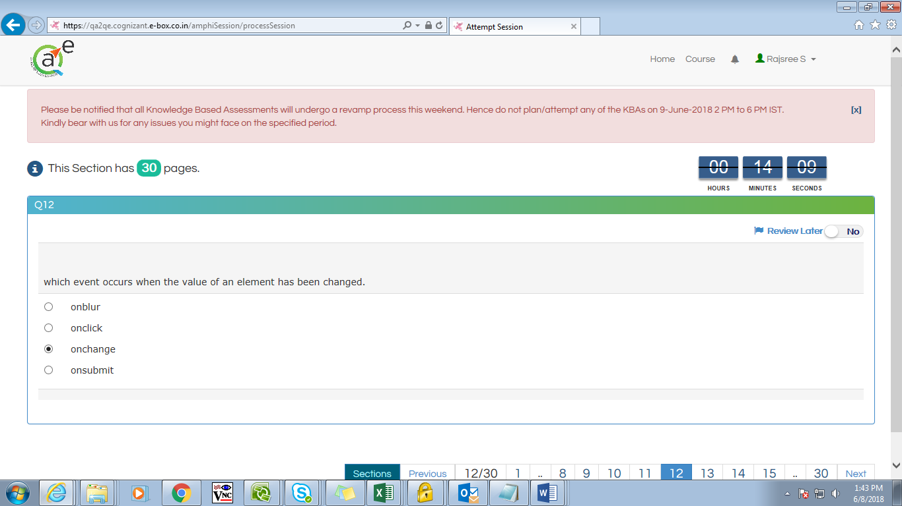

The shift method does not

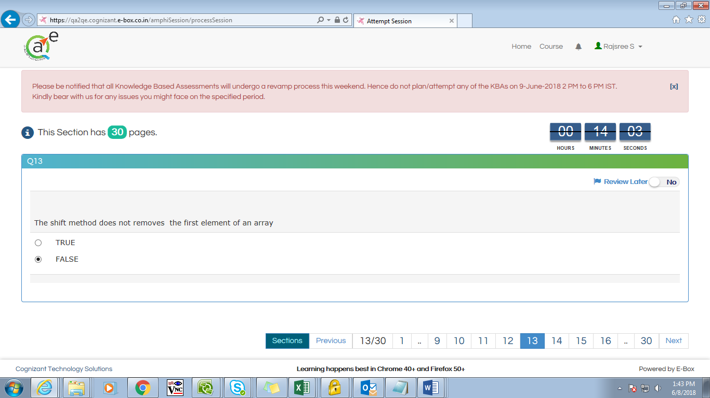

JavaScript is also called as

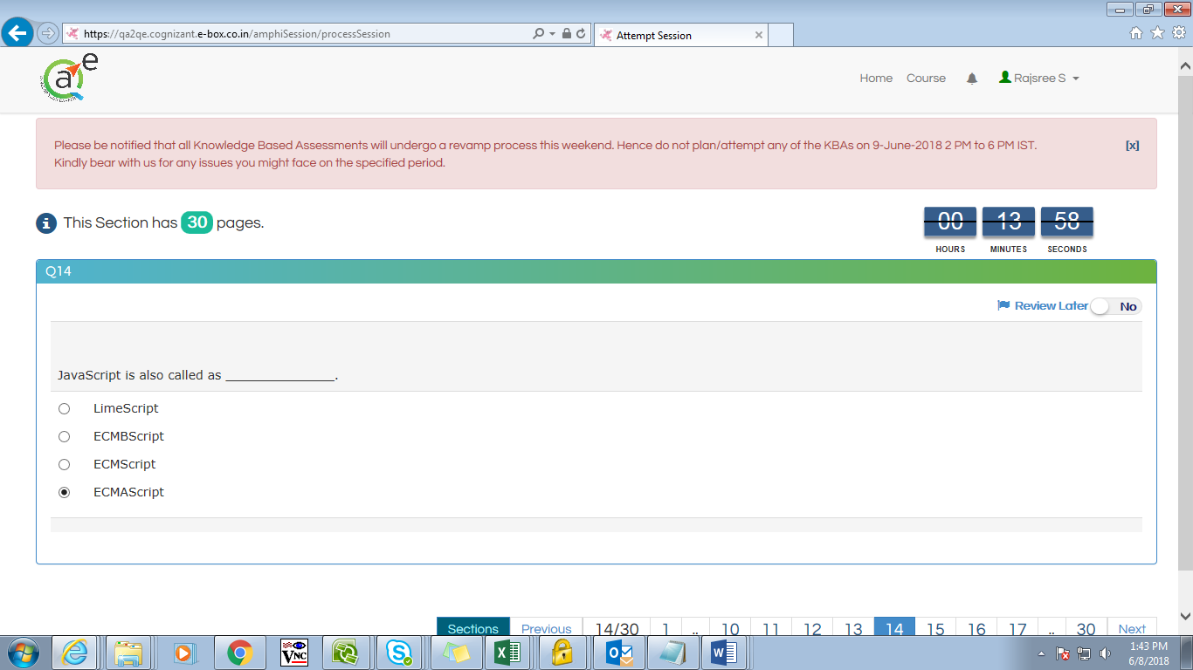

When we declare a variable within a function

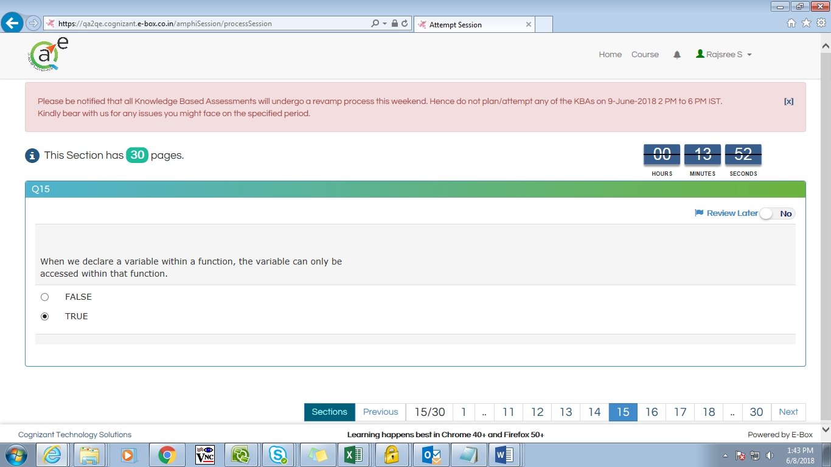

The ___ tag is used to draw graphics

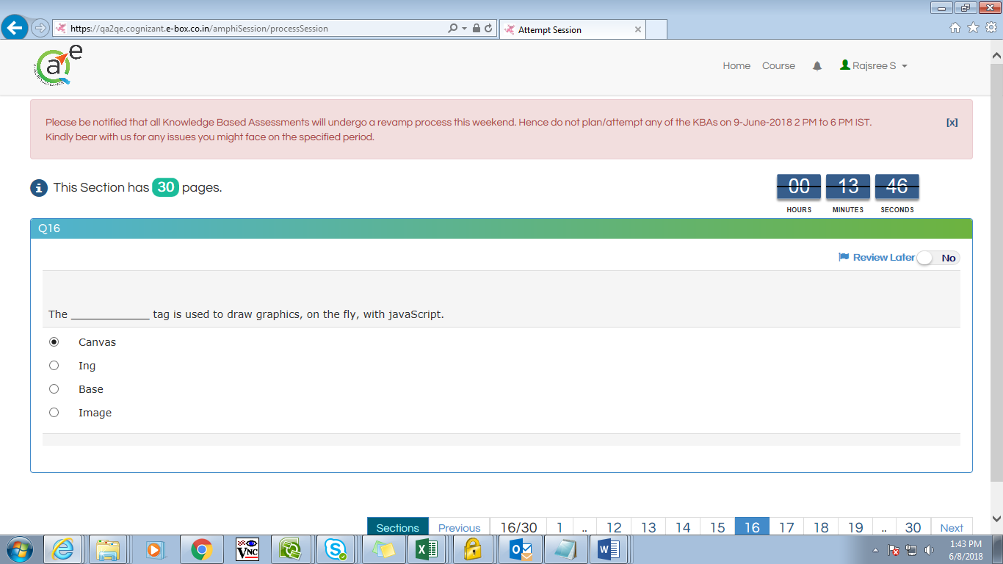

In JavaScript, Arrays are data type

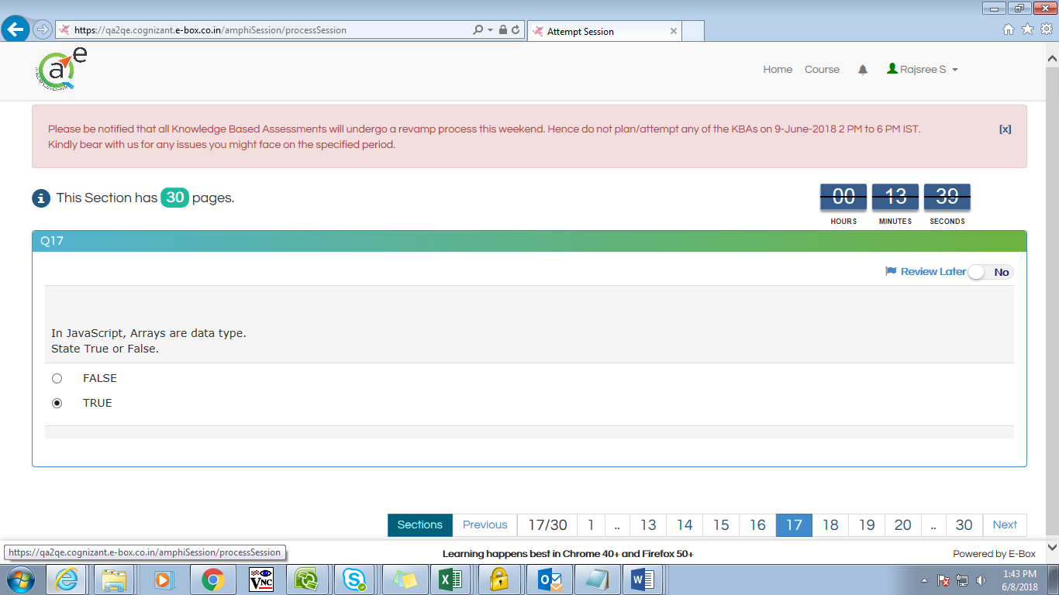

Can appear in both the <head> block and within the <block>

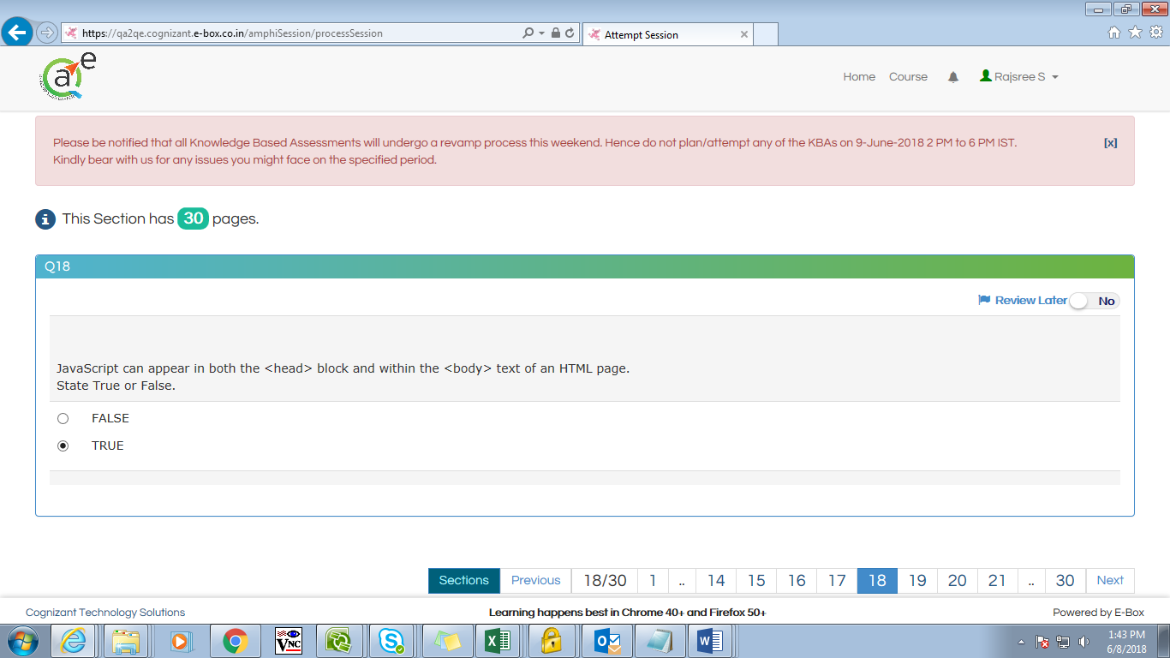

To create an Image rollover

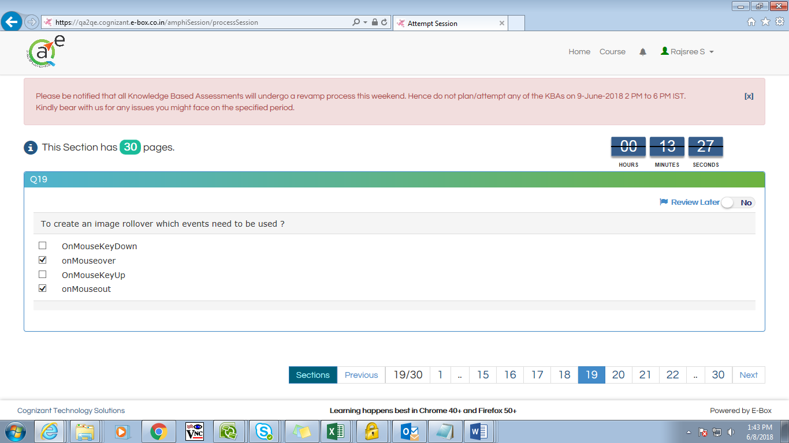

Joins all elements of an array

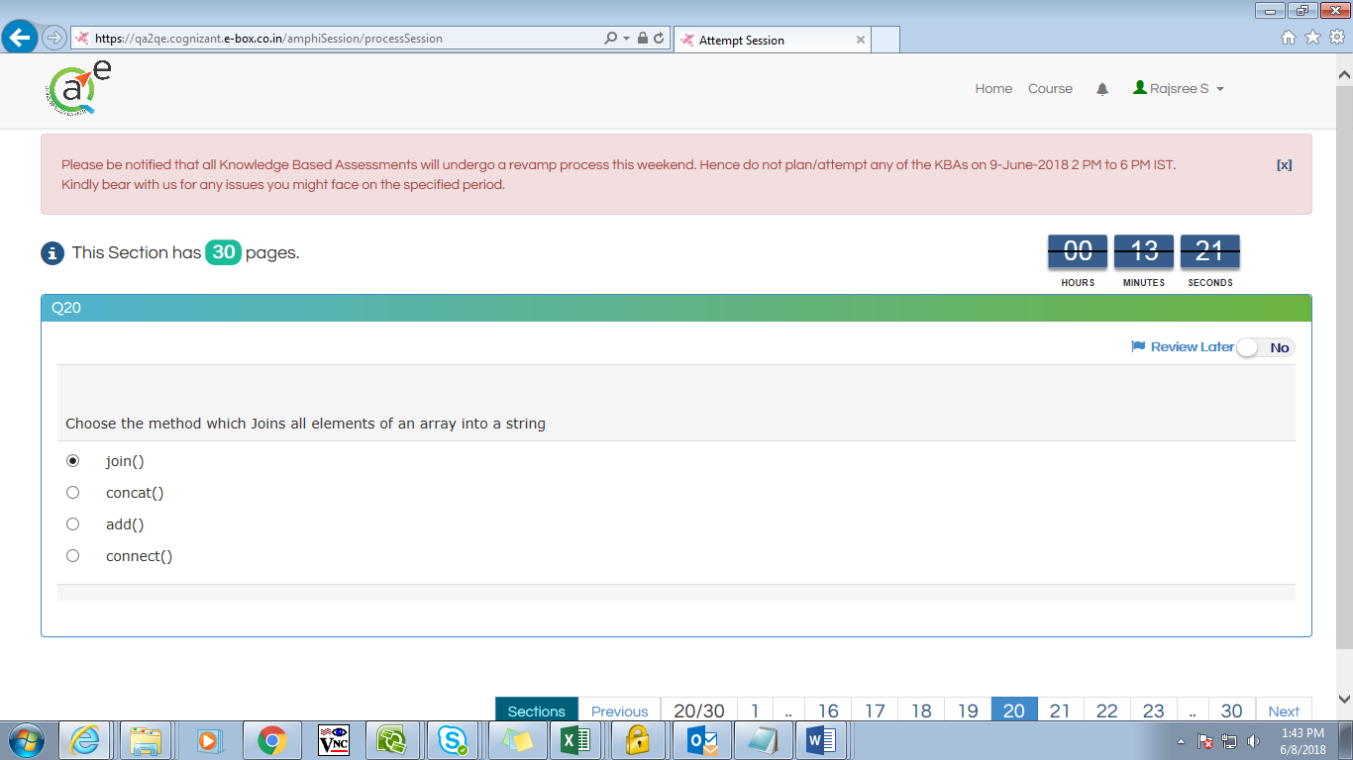

What happens if you use parseInt() to

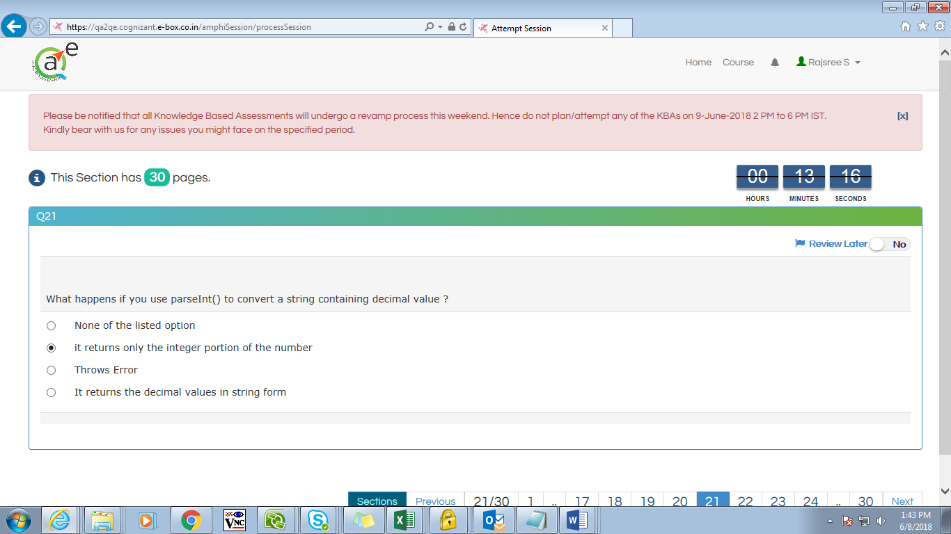

The setInterval method

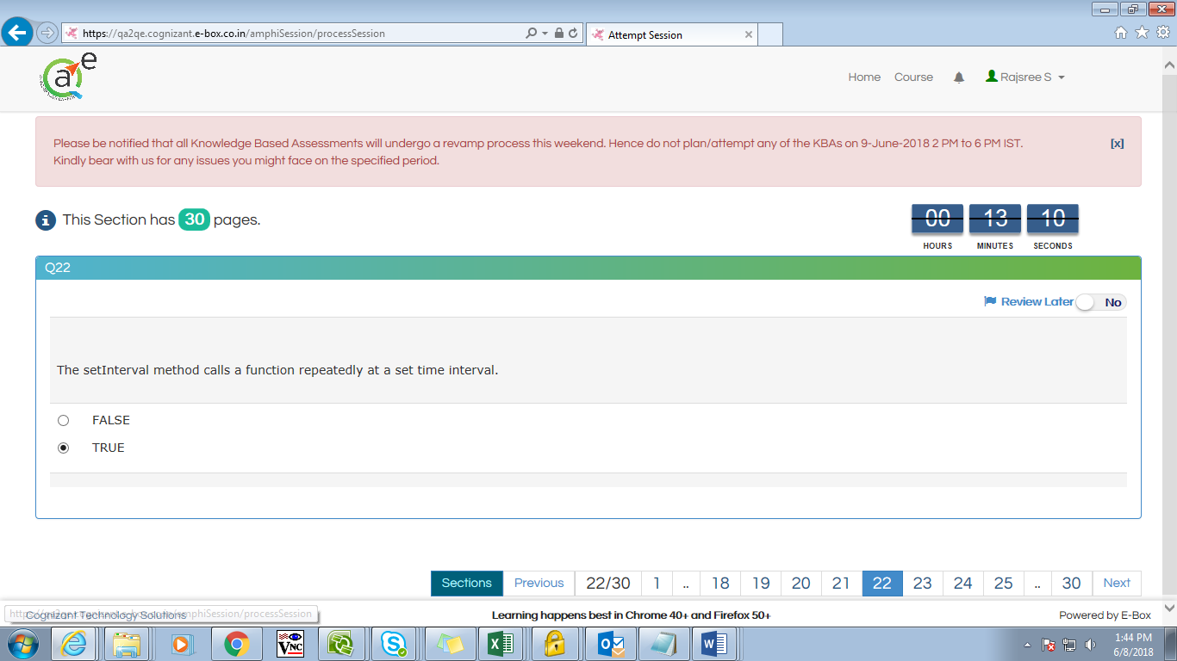

The delete operator returns a Boolean value

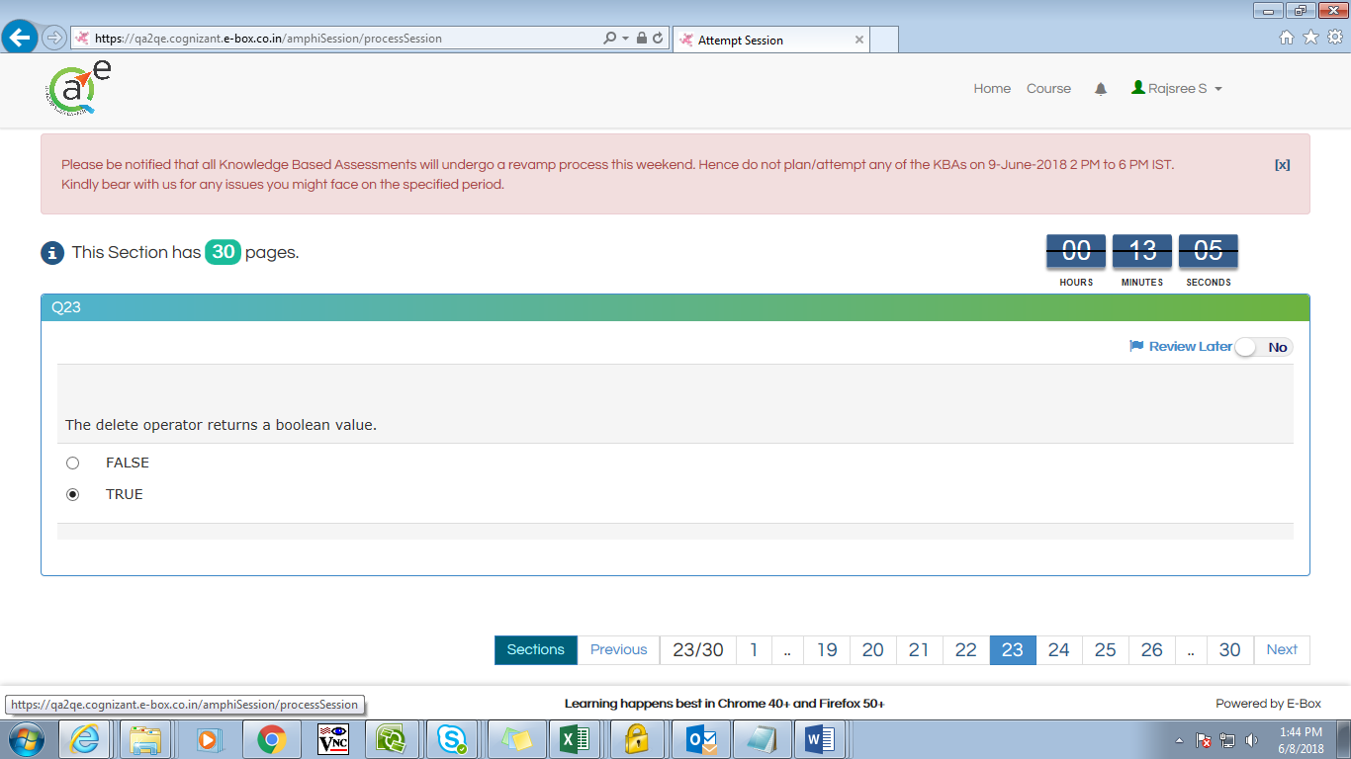

The loop type always runs the enclosed code at least once

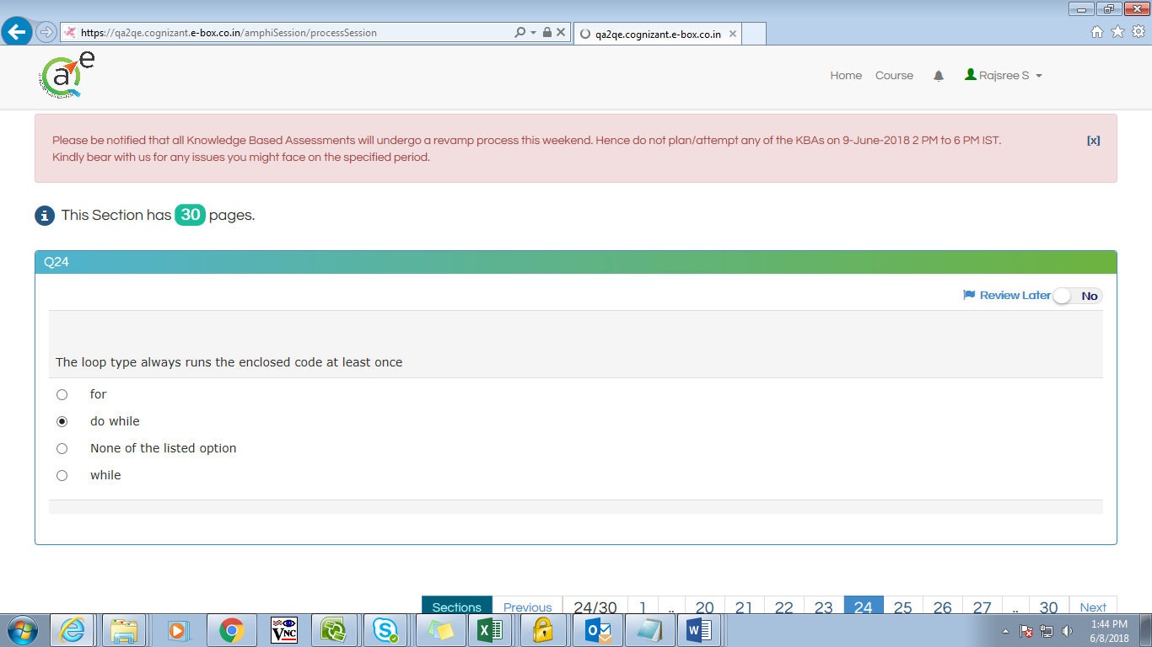

When the user is working with timing

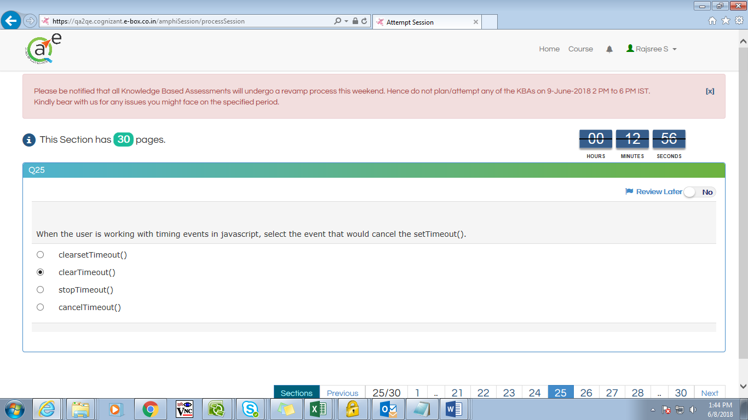

The escape() function is responsible

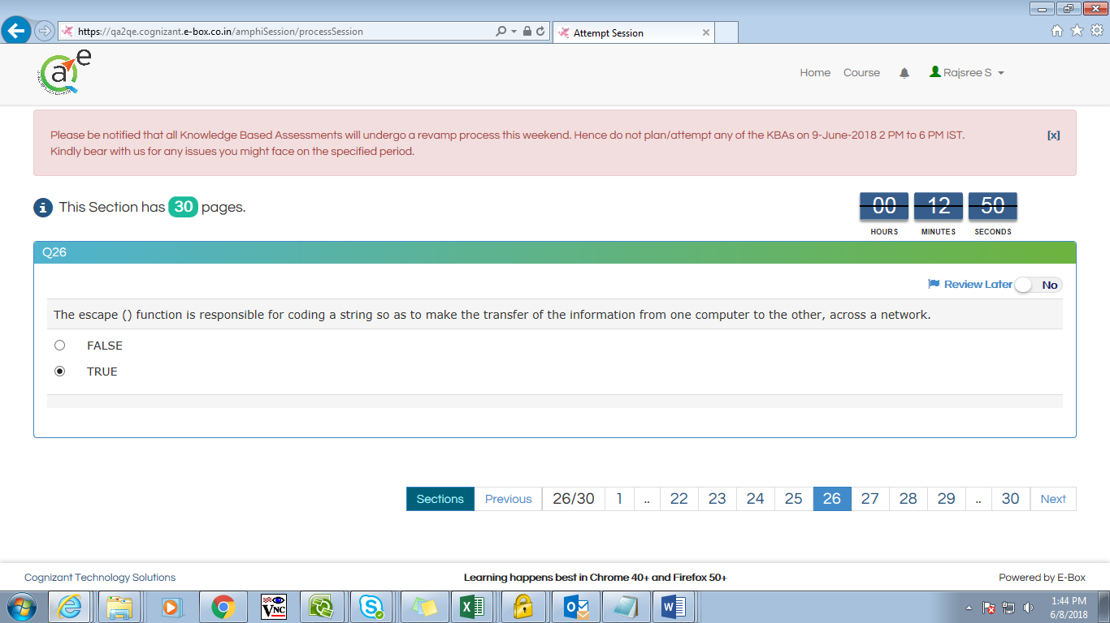

Javascript ignores extra spaces

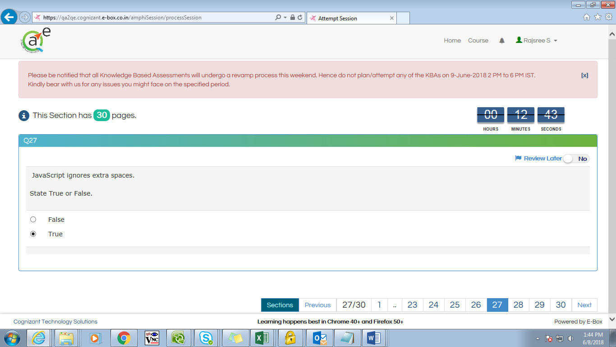

Select the javascript popup boxes from the following

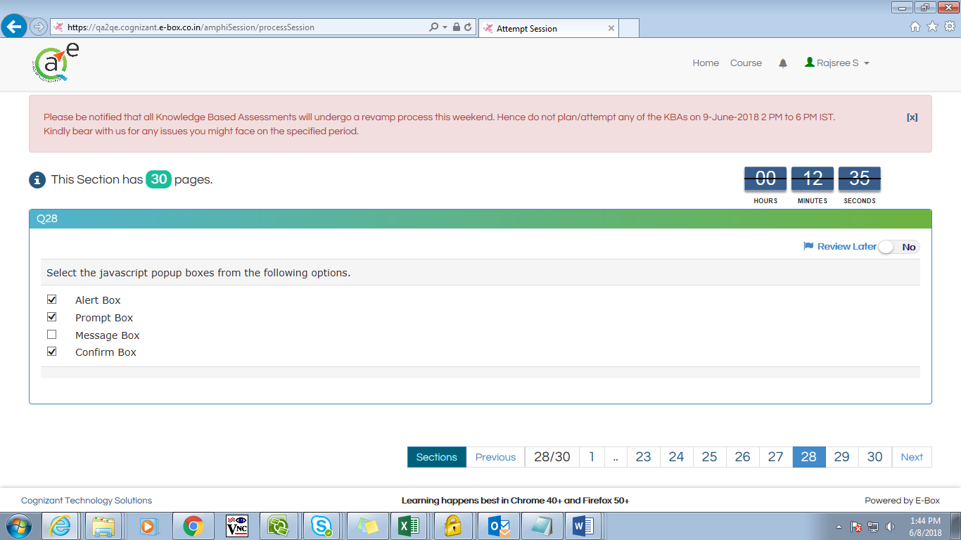

Data stored in an array always have to be the same data type

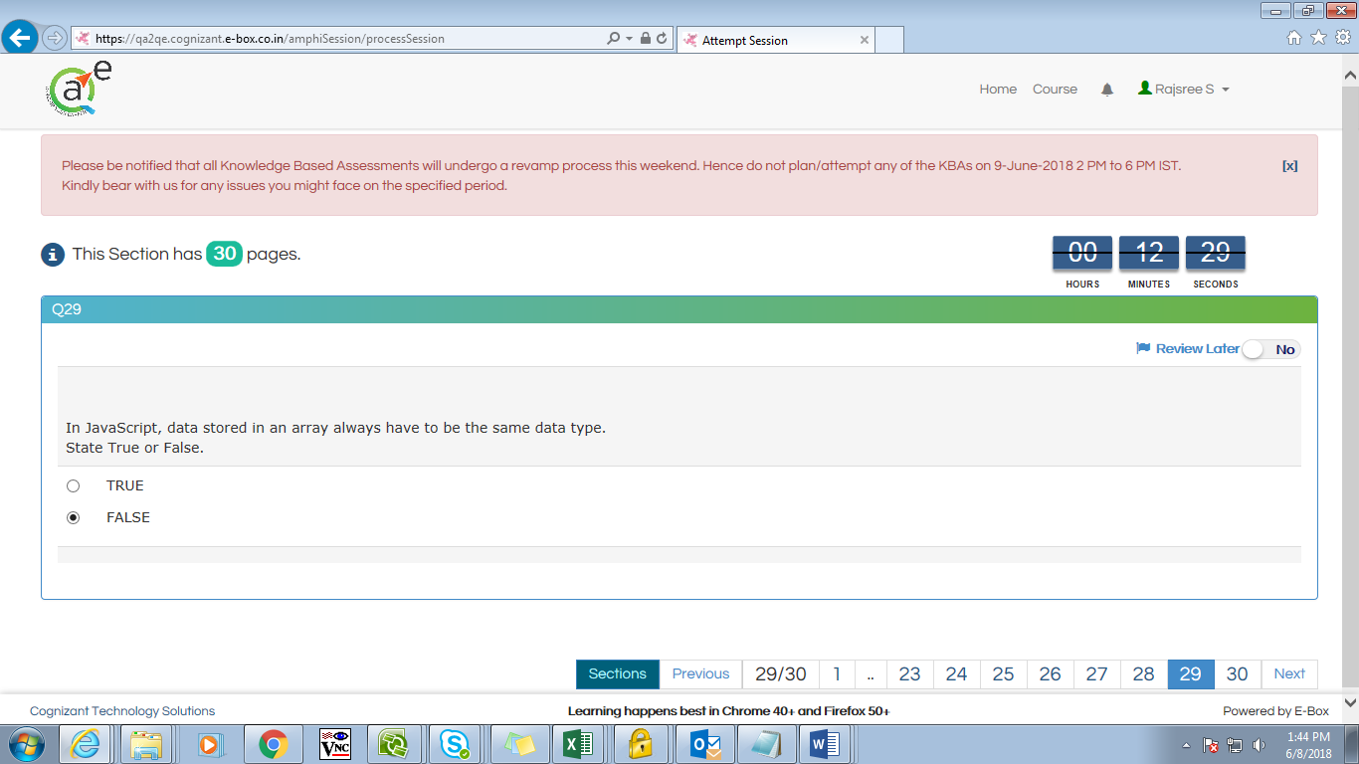

Does not allow you to read or write fields

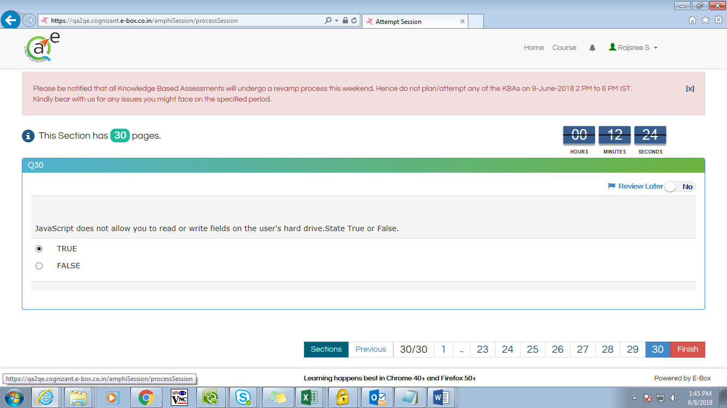

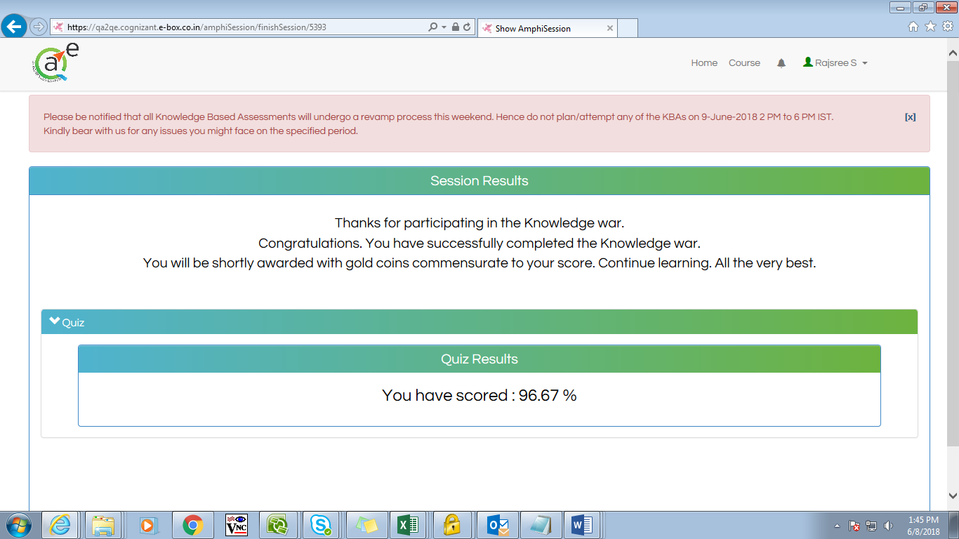

Extras!!

1. The triple equal sign === checks for equal value and equal type

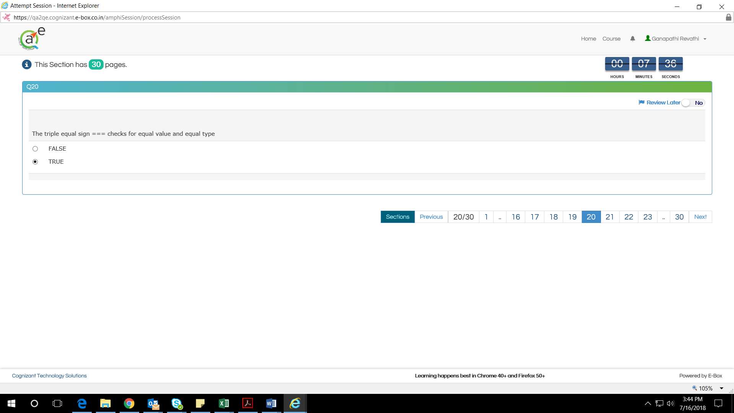

1. The shift method does not removes

{**javascript** Array: **Shift**() **Method**. The **shift**() **method** is like the pop() **method**, only it works at the beginning of the array. The **shift**() **method** pulls the first element off of the given array and returns it. This alters the array on which the **method** was called}

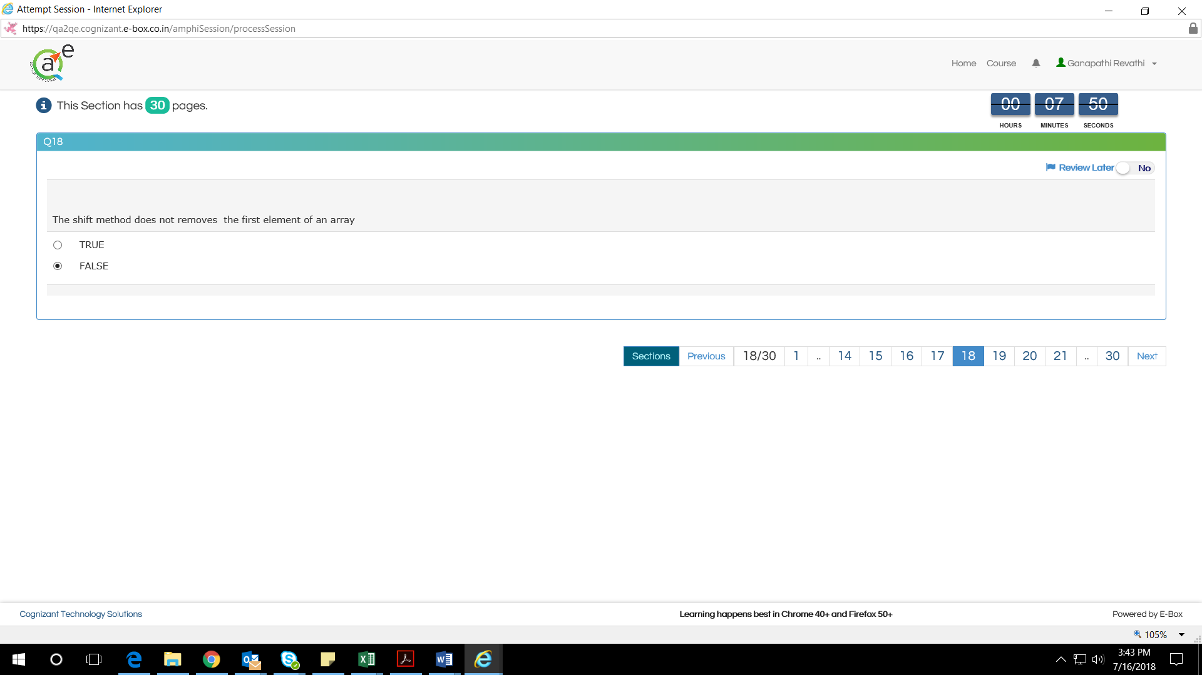

1. Javascript is also called as

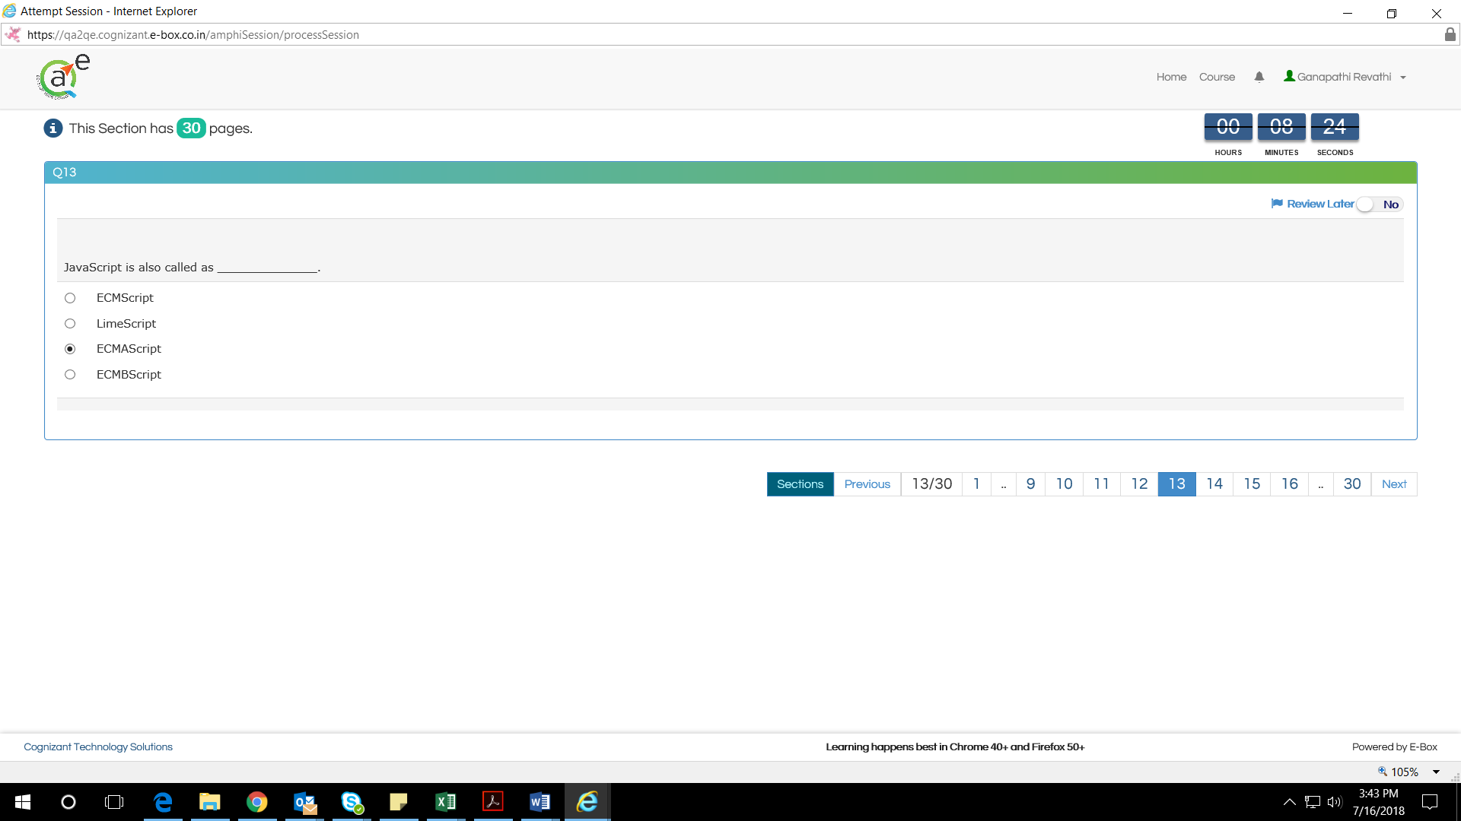

1. Alert( typeof new Date() );

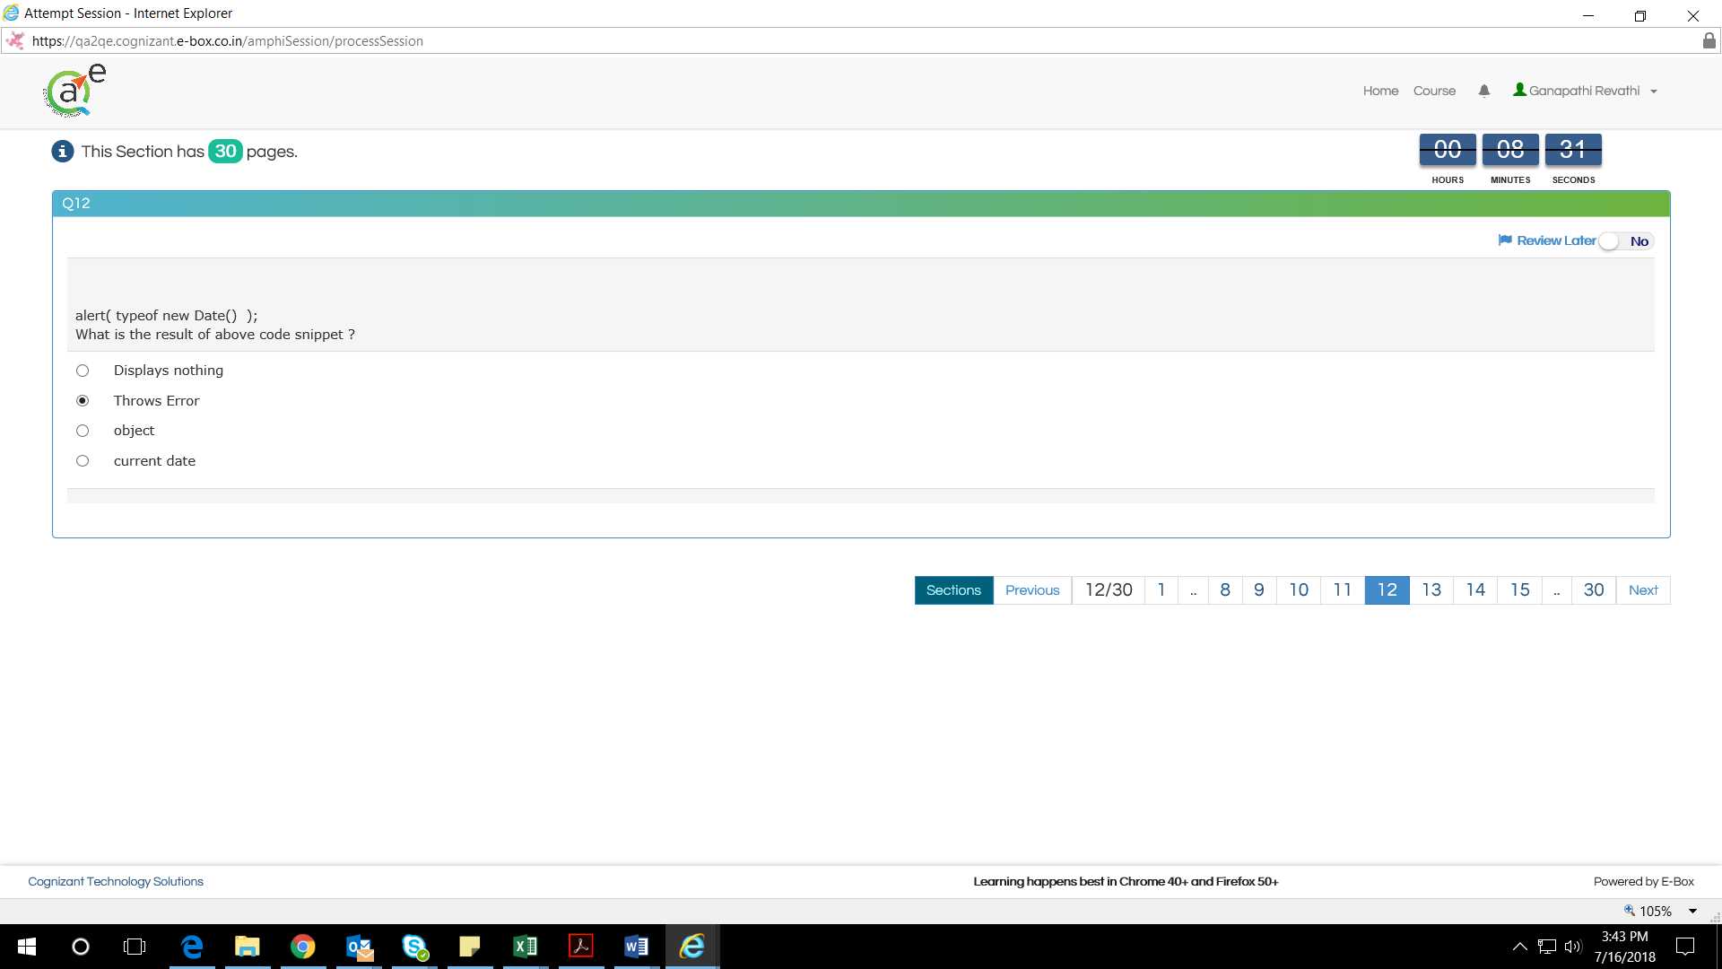

1. Prototypal or different inheritance – Class based programming

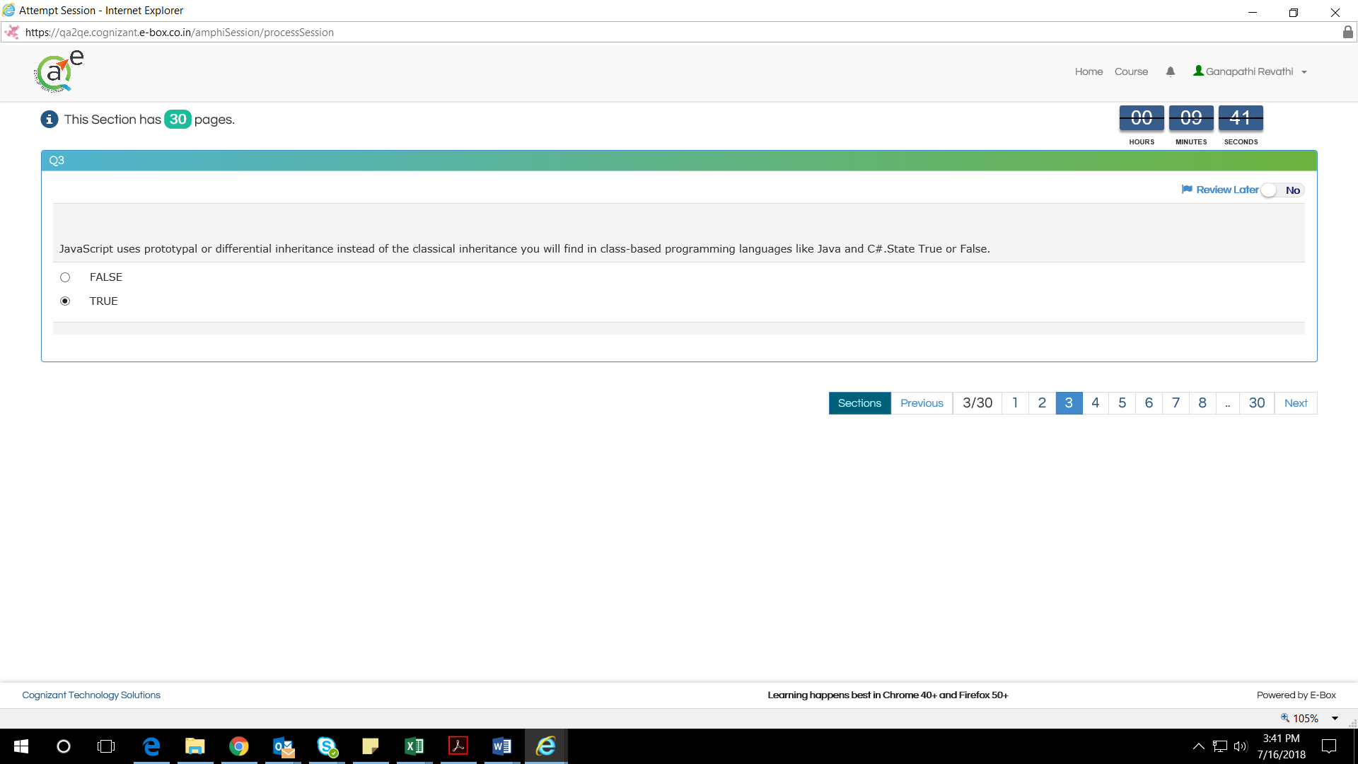

1. What value is returned by a function having no return statement when it is called in JavaScript?

The default return value is undefined for a function if no return statement is present

## What are the different loop structure available in JavaScript?

Following are the loop structure available in JavaScript.

* while
* do-while
* For

1. What is the difference between == and ===operators in JavaScript?

The == operator checks only the value for equality. Whereas, === checks both the value and the data type

1. How will you select an element in the page having id "awesome" using JavaScript?

To select an element by id we use the document.getElementById(); method.

In the following code we are selecting the element having id "awesome".

var el = document.getElementById("awesome");

## How will you select elements in a page having class "super" using JavaScript?

For this we will use the document.getElementsByClassName() method.

In the following example we are selecting all the elements in the page having class "super".

var elems = document.getElementsByClassName('super');

## 

## How will you check if a given value is not a number in JavaScript?

For this we can use the isNaN() method which returns true if the value passed is not a number otherwise, false.

1. Please see the below

